In the name of God
Research on
methods to analyze test run results
Researcher
Mohadese Akhoondi
Master
Dr Mohammad Reza Sharbaf
University Of Isfahan

comprehensive list of methods, categorized by their focus, to diagnose and analyze unit test suite failures in software development. These methods combine debugging, data analysis, code inspection, and process evaluation to pinpoint issues effectively.
- Log and Output Analysis : Examine test logs and outputs to identify failure details
Review error messages or stack traces in test logs for specific clues (e.g., NullPointerException, AssertionError). A stack trace pointing to a specific line in the code indicates where the failure occurred.
Use tools like grep, Splunk, or ELK Stack to filter and analyze test logs for patterns or recurring errors. For example Identifying repeated "timeout" errors in test runs.
Check test reports generated by frameworks (e.g., JUnit, pytest, TestNG) for failed test cases, including assertions that didn’t hold. For example A JUnit report showing which assertions failed in a test case.
Enable detailed logging in the test suite or application to capture more context (e.g., variable states, inputs). For example Adding debug logs to trace variable values before a failure.
- Code Inspection : Directly investigate the codebase and test execution.
Run the failing test in isolation to rule out interference from other tests (e.g., shared state issues).
- Test Environment Analysis
Verify that the test environment (e.g., OS, dependencies, configurations) matches the expected setup.

Check versions of dependencies, frameworks, or external services (e.g., databases, APIs) for compatibility issues.
Investigate if system resources (e.g., CPU, memory, disk) were overloaded during the test run.
Review configuration files or environment variables for incorrect settings.For example a test failing because a database connection string is misconfigured.

- Test Design and Logic Analysis : Evaluate the test suite’s design and assumptions.
Check if assertions are correct and test the intended behavior.
Verify that input data or mocks used in tests are valid and representative.
Ensure tests are independent and not affected by shared state or test order.
Check if tests cover edge cases or boundary conditions that might cause failures.For example A test failing because it didn’t account for a null input.
Identify tests that fail intermittently due to non-deterministic behavior (e.g., race conditions, random inputs).For example Rerunning a failing test multiple times to confirm flakiness.
- Comparative Analysis : Compare test runs or code versions to isolate issues.
Compare current test results with previous successful runs to identify changes that caused failures.

Run tests with different configurations or versions of the code to isolate the cause.
Correlate test failures with recent code changes using version control history(Use git blame or git bisect to identify commits introducing failures.).

- Root Cause Analysis (RCA) Techniques :
Repeatedly ask “why” to drill down to the root cause of a failure.For example Why did the test fail? → Assertion error. Why? → Incorrect output. Why? → Bug in the logic.
Categorize potential causes (e.g., code, environment, test design) to identify the root issue.
Fault Tree Analysis which is Modeling logical relationships between events leading to test failure.

Identify untested or poorly covered code paths that may contribute to failures(Test Coverage Gap).

a list of GitHub projects that provide analytical reports on test execution results. These tools help developers better analyze test outcomes
Test Reporting Tools
- Test Reporter: A tool for displaying test results in the GitHub UI, compatible with frameworks like xUnit and JUnit.
- GitHub Test Reporter: Enables publishing and viewing test reports directly in GitHub Actions.
- XCTestHTMLReport: Generates Xcode-style HTML reports for Unit and UI tests.
- CI::Reporter: A Ruby framework plugin for generating XML reports for CI systems.
- Allure Report: A multilingual reporting tool with clear graphical dashboards, supporting Selenium, TestNG, and more.
- Cluecumber: A Maven plugin for generating Cucumber BDD test reports.
- TestBeats: A tool for publishing test results to platforms like Microsoft Teams and Slack.
- ExtentReports: A reporting API for automated tests, particularly for Java.
- ReportPortal: An advanced analytics reporting service with Jenkins integration.
- ReportNG: An HTML/XML reporting plugin for TestNG (no longer maintained).
- pytest-html: A plugin for generating HTML reports for pytest results.
- jest-html-reporter: Generates HTML reports for Jest test results.
- Spock Reports: Produces HTML reports for Spock specifications.
Project Name | Description | GitHub Link
Test Reporter | Displays test results in the GitHub UI for frameworks like xUnit and JUnit. | https://github.com/dorny/test-reporter
GitHub Test Reporter | Publish and view test reports in GitHub Actions; suitable for all major frameworks. | https://github.com/ctrf-io/github-test-reporter
XCTestHTMLReport | Generates Xcode-like HTML reports for Unit and UI tests, with support for parallel testing. | https://github.com/TitouanVanBelle/XCTestHTMLReport
CI::Reporter | Plugin for Ruby frameworks like Test::Unit; produces XML reports for CI. | https://github.com/ci-reporter/ci_reporter
Allure Report | Multilanguage reporting tool with graphical charts; works with Selenium, TestNG, and more. | https://github.com/allure-framework/allure2
Cluecumber | Maven plugin that builds test reports for Cucumber BDD from JSON files. | https://github.com/trivago/cluecumber
TestBeats | Publishes test results to platforms like Microsoft Teams and Slack; supports multiple frameworks. | https://github.com/test-results-reporter/testbeats
ExtentReports | Reporting API for automated tests—especially Java—with extensive customization options. | https://github.com/extent-framework/extentreports-java
ReportPortal | Hosted reporting service with advanced analytics; integrates with Jenkins, Jira, and Cucumber. | https://github.com/reportportal/reportportal
ReportNG | HTML/XML reporting plugin for TestNG (no longer maintained). | https://github.com/dwdyer/reportng
pytest-html | Plugin that creates HTML reports for pytest results; ideal for Python tests. | https://github.com/pytest-dev/pytest-html
jest-html-reporter | Generates an HTML report for Jest test results; suited to JavaScript projects. | https://github.com/Hargne/jest-html-reporter
Spock Reports | Produces HTML reports for Spock specifications; intended for Groovy tests. | https://github.com/renatoathaydes/spock-reports

Resources
Allure Report
TestBeats
pytest-html

Output parameters of existing project on github
1.
https://github.com/marketplace/actions/test-reporter
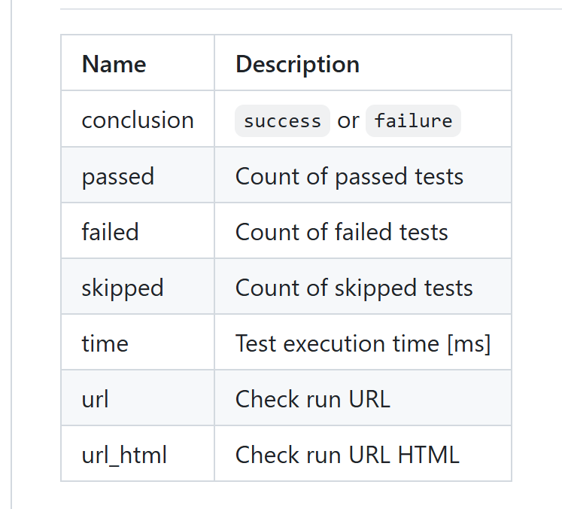

2.
https://github.com/ctrf-io/github-test-reporter?tab=readme-ov-file
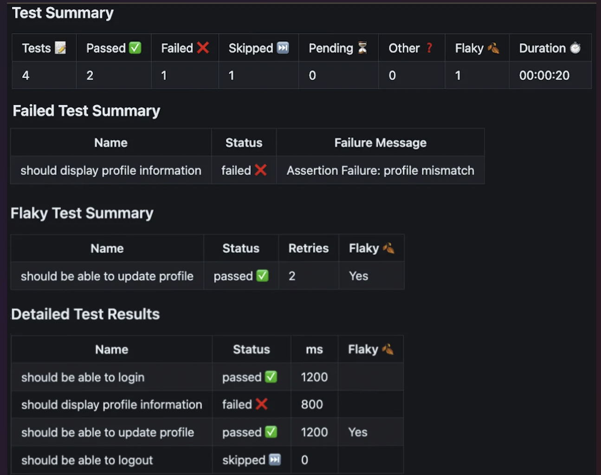
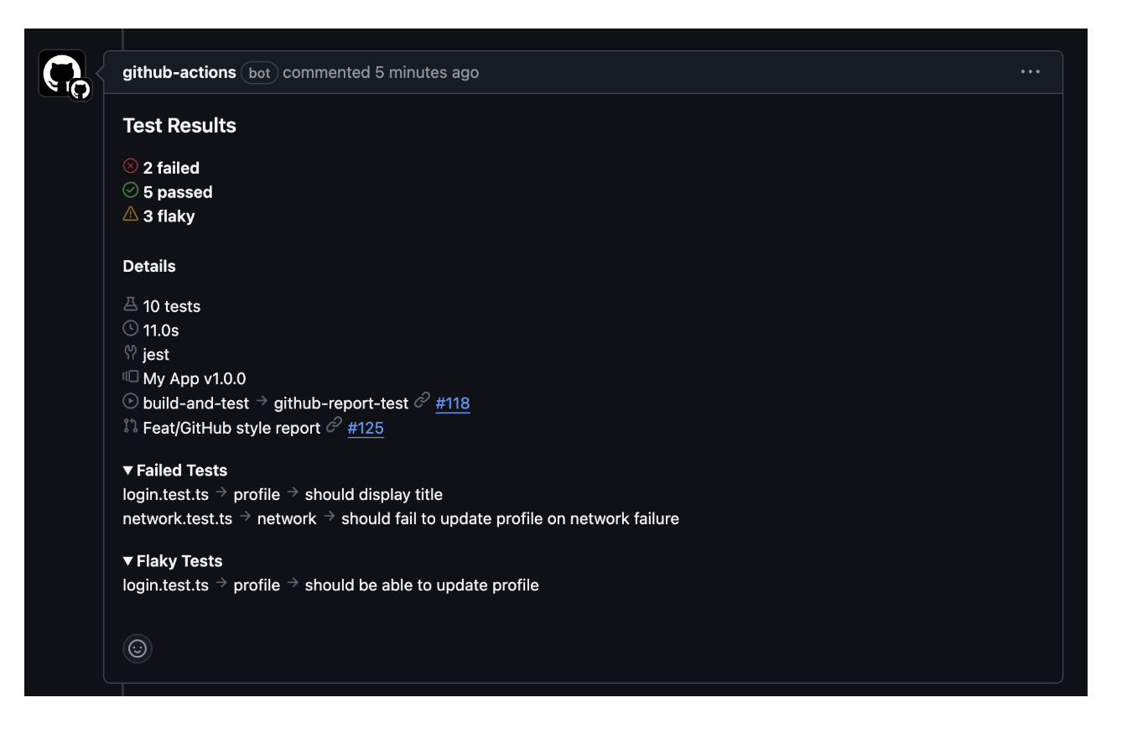
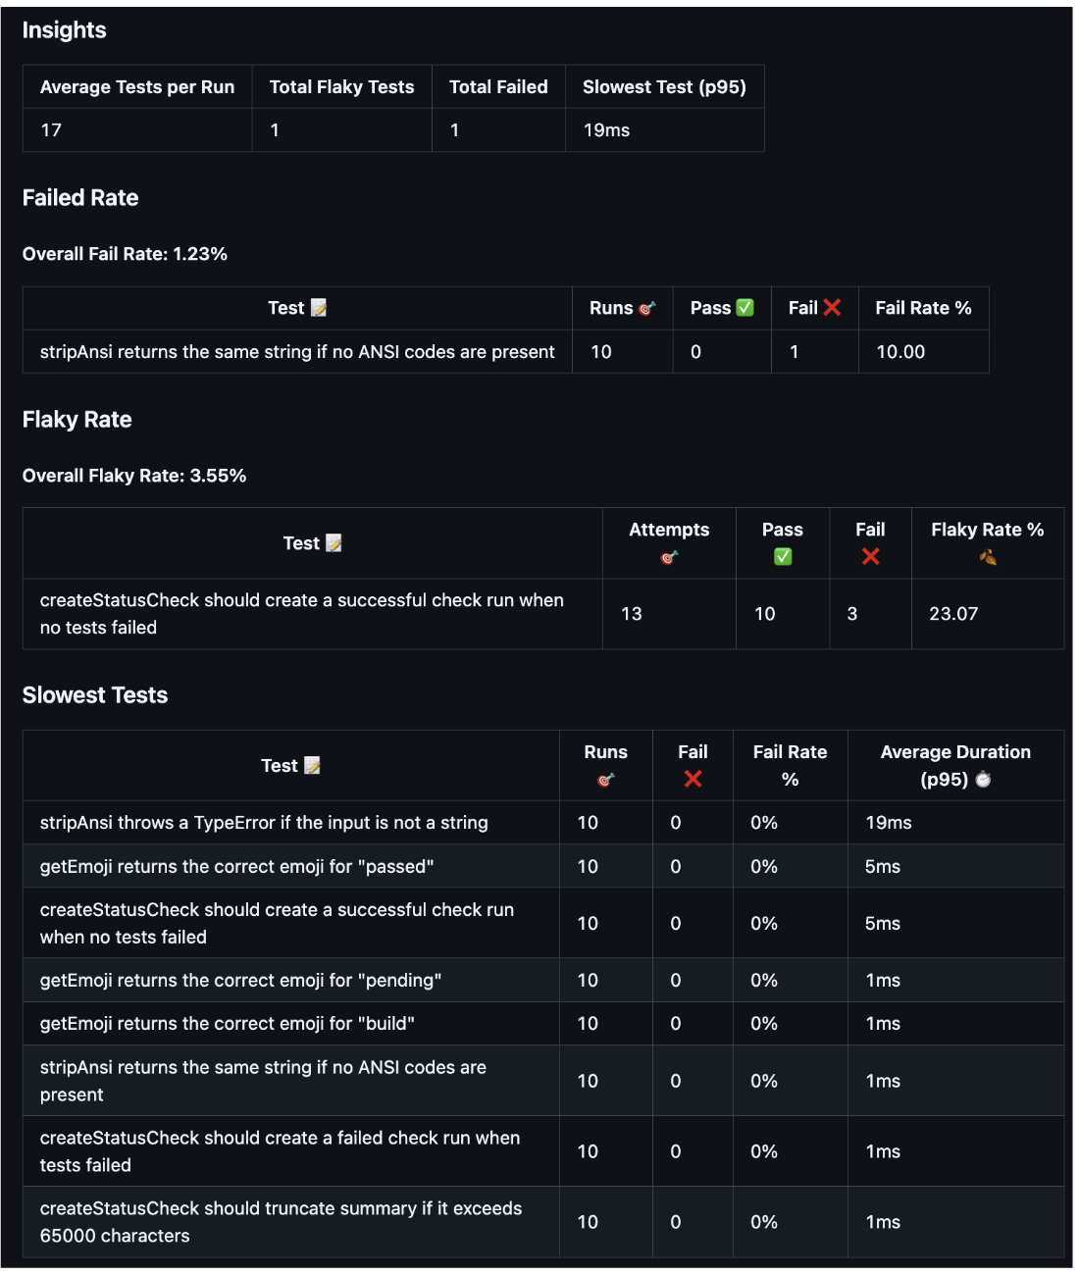

3.
This site includes all github links of Open Source Test Reporting Tools
https://www.softwaretestingmagazine.com/tools/open-source-test-reporting-tools/
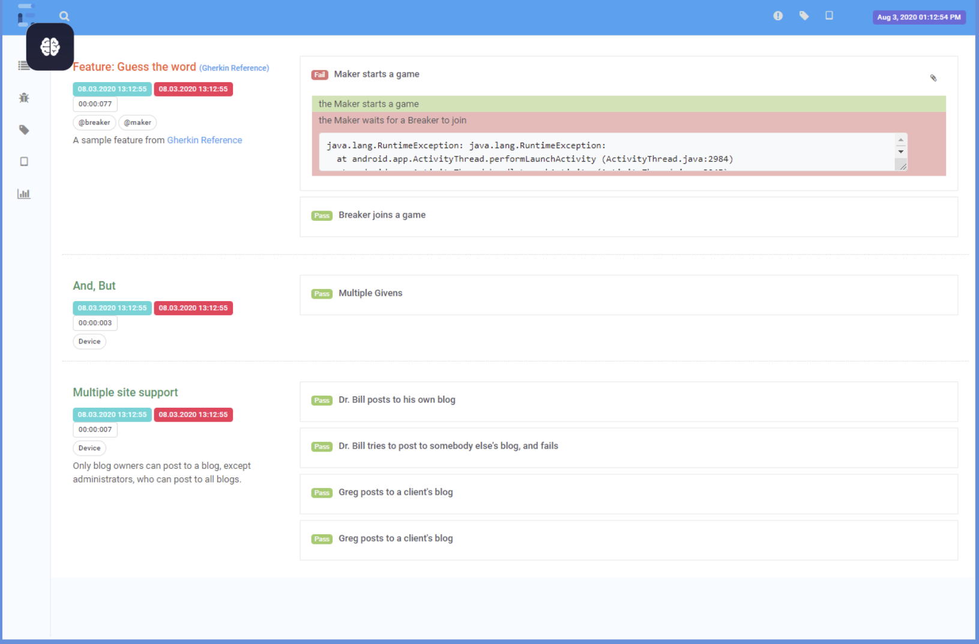

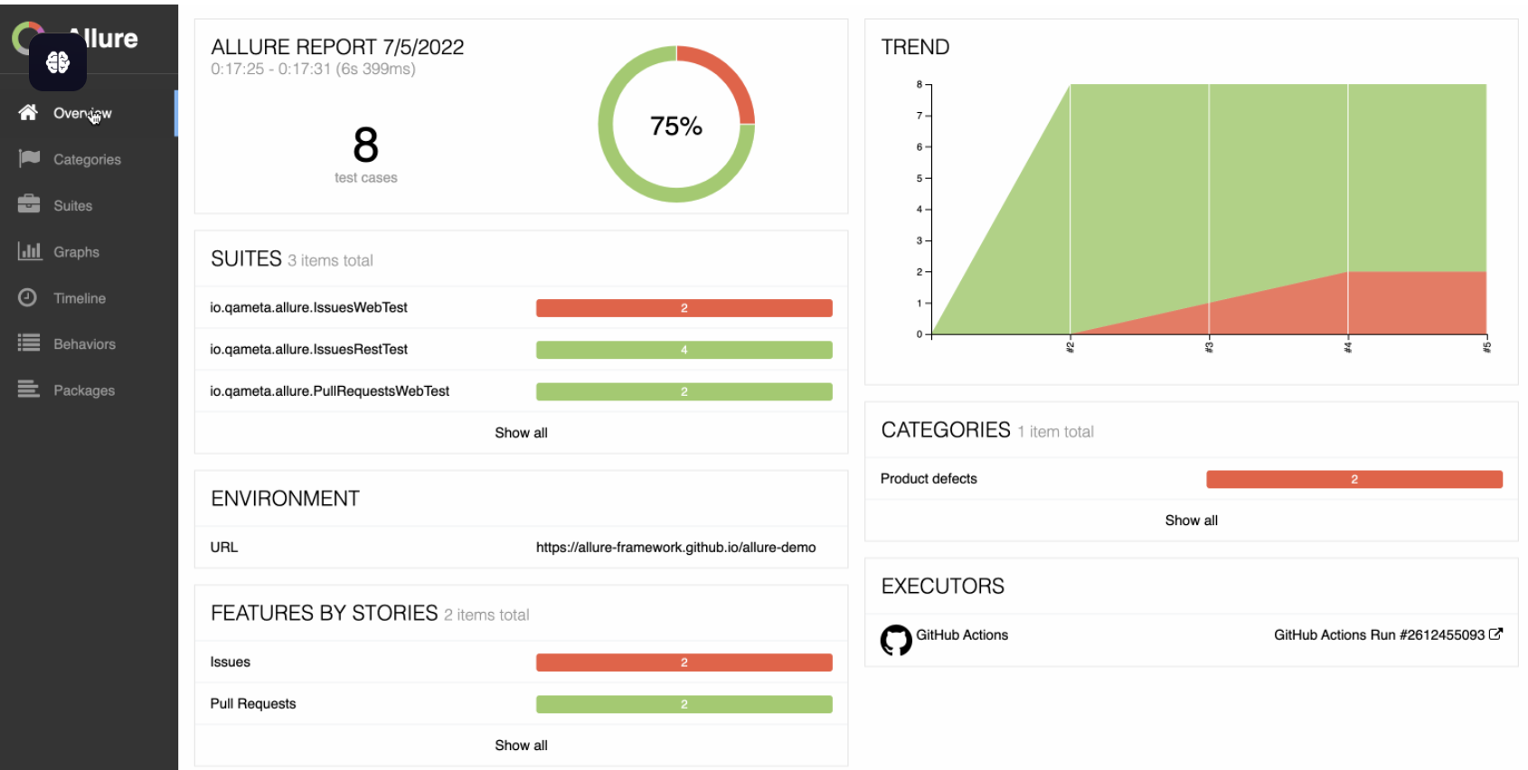
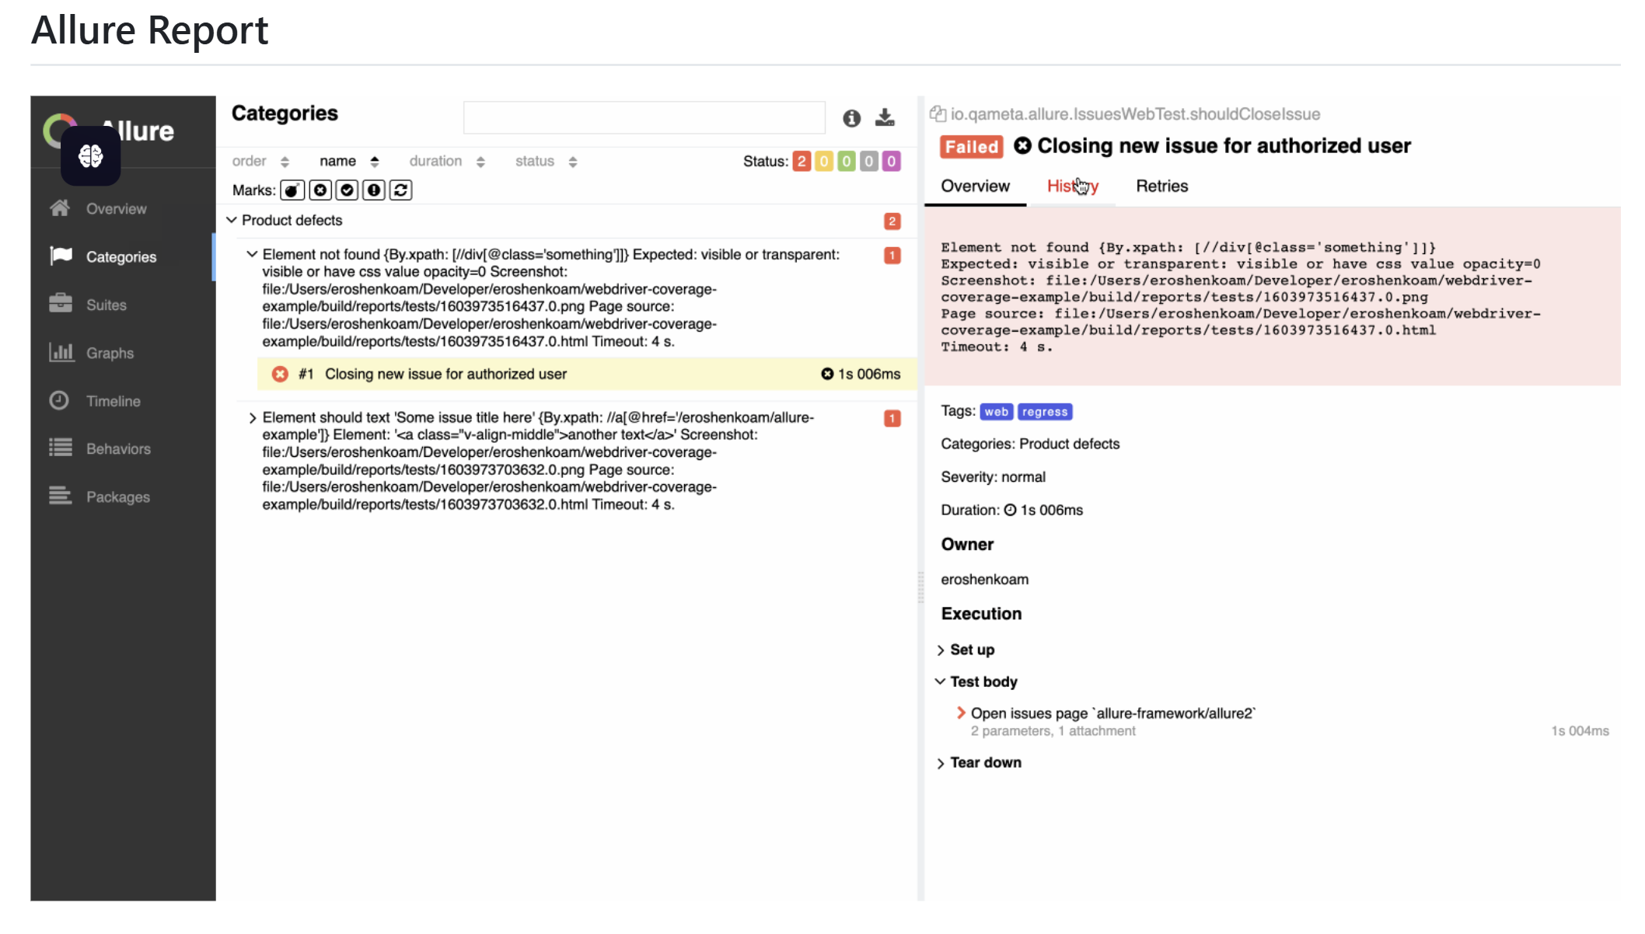
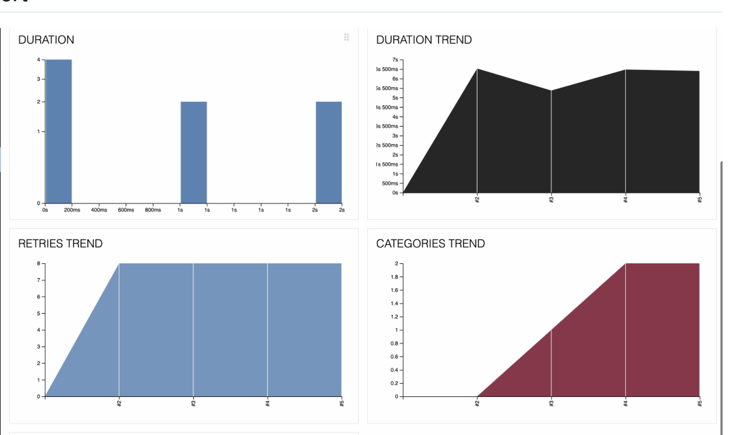
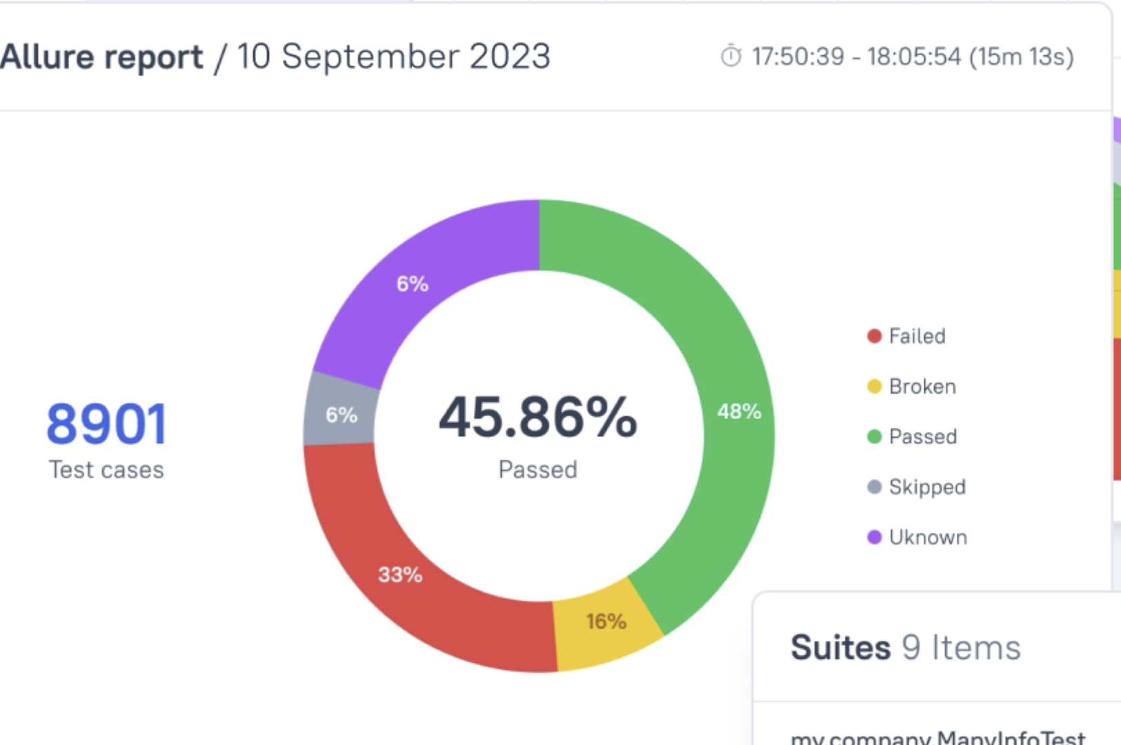

Also more tools
Tool Name | GitHub Link | Output Parameters
Allure Framework | https://github.com/allure-framework | Detailed test-case steps; attachments (screenshots, logs); defect classifications; historical data; multi-OS compatibility
ExtentReports / Klov | https://github.com/extent-framework | Web-based reports; historical analysis; interactive charts; detailed test logs; integration with testing frameworks
ReportPortal | https://github.com/reportportal/reportportal | Real-time reports; analytics; full test-history logs; AI/ML analysis; defect reports; CI/CD integration
CI::Reporter | https://github.com/ci-reporter/ci_reporter | XML reports in JUnit format: test suite & case details, statuses, execution times, failure messages
Cluecumber Report Maven Plugin | https://github.com/trivago/cluecumber-report-plugin | Aggregated reports from Cucumber JSON: feature, scenario, and step details; pass/fail statuses
Go-allure | https://github.com/robotomize/go-allure | Allure reports for Go tests: detailed test information and attachments
HtmlTestRunner | https://github.com/oldani/HtmlTestRunner | HTML reports for Ruby tests: test-case names, statuses, and error messages
Jasmine Reporters | https://github.com/larrymyers/jasmine-reporters | JUnitXmlReporter for Jasmine: XML reports with test details, statuses, and times
jest-html-reporter | https://github.com/Hargne/jest-html-reporter | HTML summaries for Jest: test-suite and test-case details; pass/fail statuses
jest-html-reporters | https://github.com/Hazyzh/jest-html-reporters | HTML reports for Jest with detailed suite/case results and statuses
karma-htmlfile-reporter | https://github.com/matthias-schuetz/karma-htmlfile-reporter | Styled HTML files for Karma: test results per browser; separate tables for each browser
Next Gen Report | https://github.com/iambalabharathi/nxgreport | E-mailable HTML/PDF reports for Ruby tests: test results and summaries
ReportBuilder | https://github.com/rajatthareja/ReportBuilder | Mobile-friendly HTML/JSON reports for Cucumber: test details and retry files
ReportNG | https://testng.org/reportng/ | HTML and XML reports for TestNG: categorized test results with detailed information
Spock Reports | https://github.com/renatoathaydes/spock-reports | HTML reports for Spock: summary index, customizable templates, detailed test info
XCTestHTMLReport | https://github.com/TitouanVanBelle/XCTestHTMLReport | Xcode-like HTML reports: Unit/UI test results, parallel-testing support, attachments

Here’s an AI Test Reporter for Playwright — Summarize Test Results
https://medium.com/@ma11hewthomas/playwright-with-ai-generated-test-summaries-fd669c9ce458
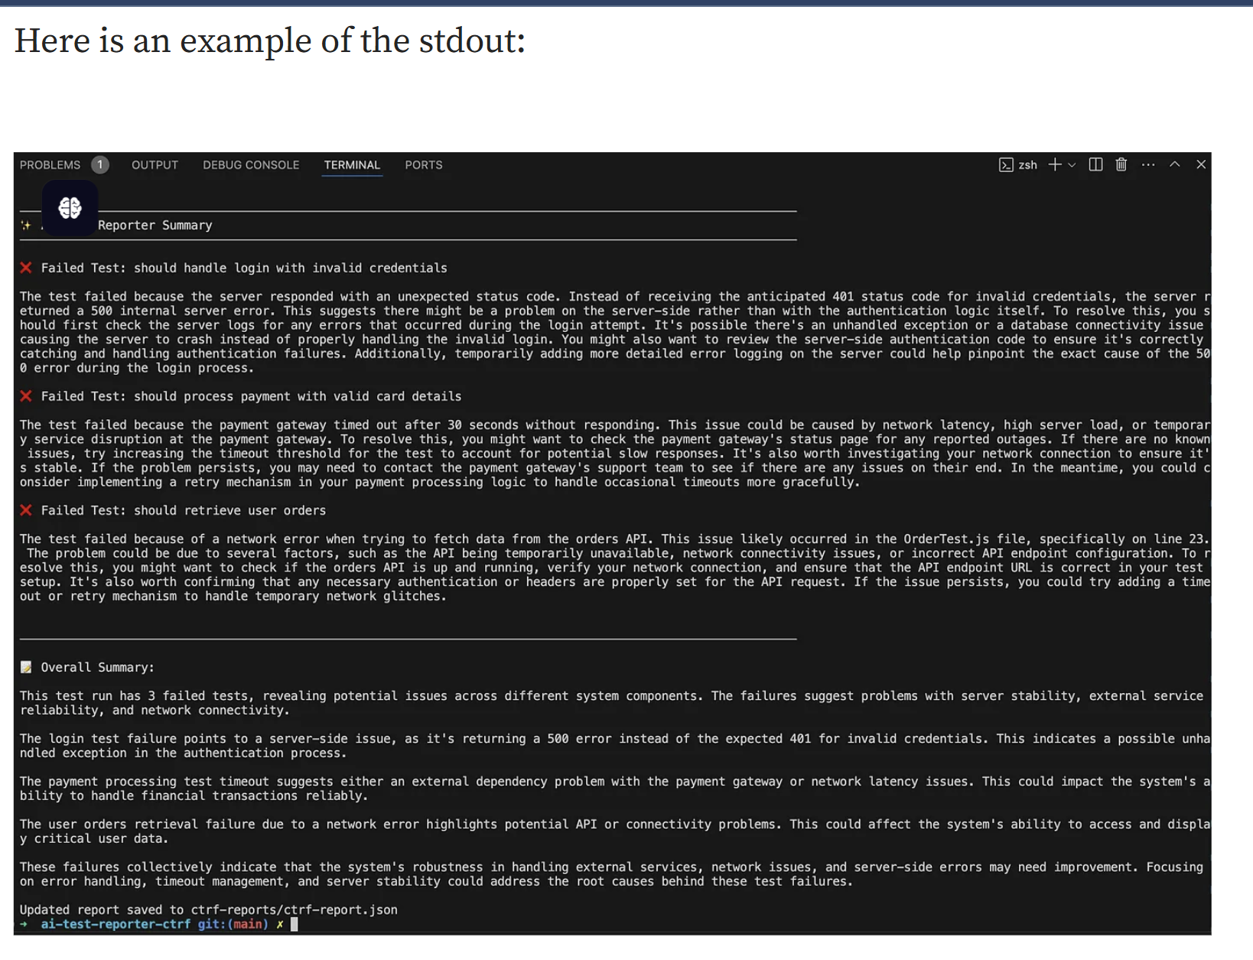
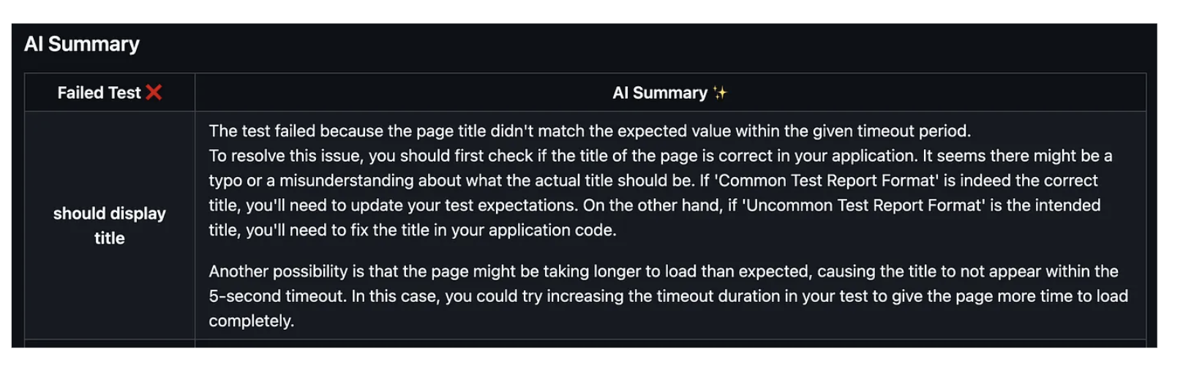
https://www.testmo.com/github-test-management/
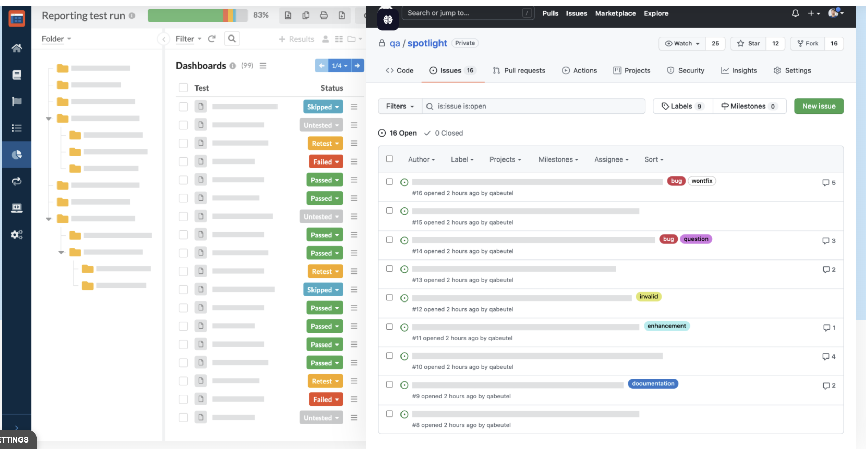
https://reportportal.io/
I used Demo of this product and it’s all output parameters
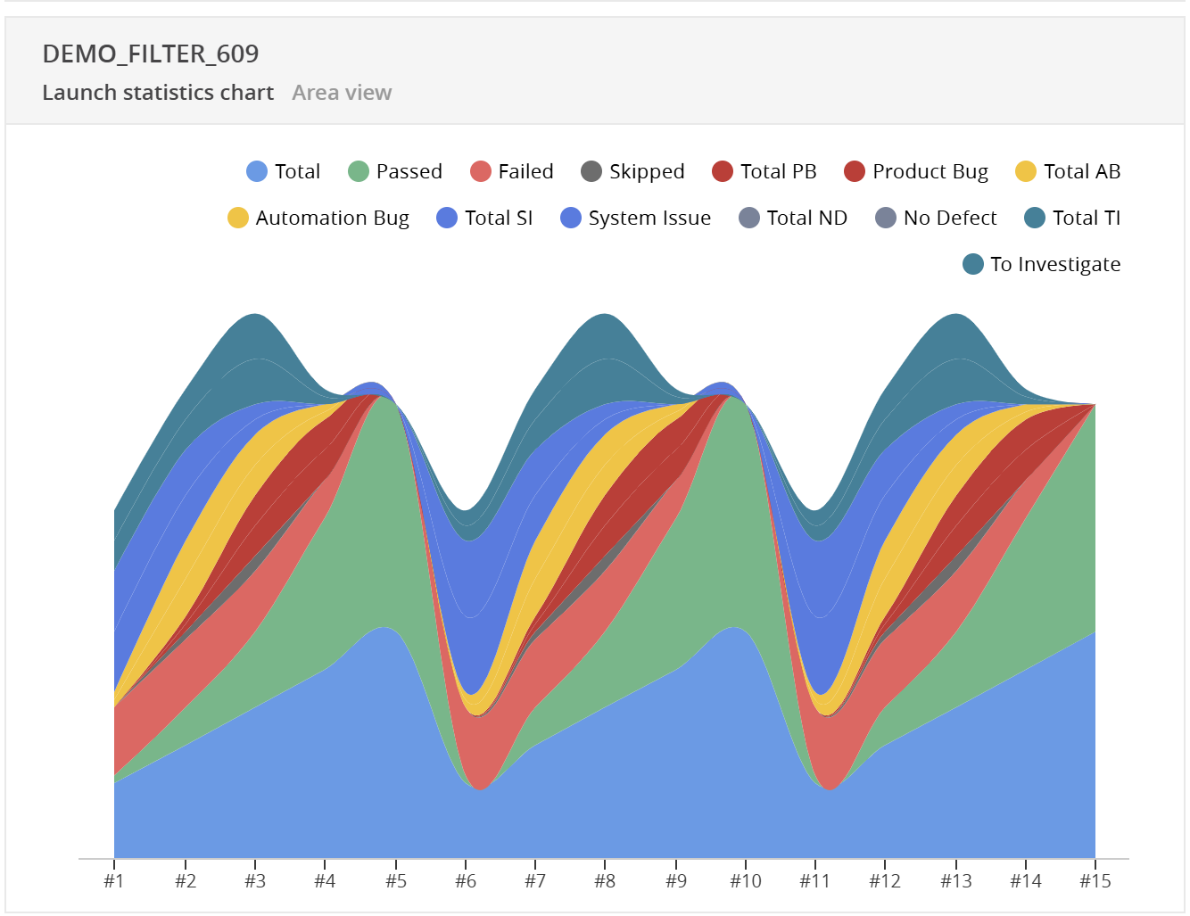
Table of above picture parameters
Legend Entry | Meaning (per launch) | Typical Use-Case for a Developer
Total (blue) | Total number of test items executed in that launch (passed + failed + skipped). | Quick sense of launch size / workload.
Passed (green) | Items whose assertions all succeeded. | Confirms coverage that is already stable.
Failed (red) | Items that ended with a FAILED status but have not yet been assigned any defect type. | Pool of failures that still need triage.
Skipped | Items the runner declared skipped / ignored / disabled. | Reveals tests muted by feature flags, @Disabled, etc.
Product Bug | A failed item tagged as a defect in the application under test. | Signals real functional issues to product engineers.
Total PB | Sum of all Product-Bug sub-types (e.g., PB001-UI, PB002-API). | High-level view of product quality.
Automation bug | Failure caused by an error in the test script, framework, or data. | Points QA/automation engineers to flaky or outdated tests.
Total AB | Aggregate of every Automation-Bug subtype. | Shows how much of the red is self-inflicted by the test harness.
System Issue | Failure rooted in the infrastructure (CI node down, DB unreachable, OOM, etc.). | Escalate to DevOps rather than product devs.
Total SI | Sum of all System-Issue sub-types. | Separates infra instability from code regressions.
No Defect | Item marked as “works as designed” or “expected change”; not counted as a bug. | Keeps noise out of bug metrics.
Total ND | Combined view of all “No Defect” sub-types. | High-level false-positive gauge.
To Investigate | Default tag for a new failure that no one has triaged yet. | Personal inbox for the next triage round.
Total TI | Total of every “To Investigate” subtype (if any). | Lets leads see the triage backlog size.

